**Detailed Steps for Image Transformation using CycleGAN**

**Understanding CycleGAN**

**Overview**: CycleGAN is a type of Generative Adversarial Network (GAN) that enables unpaired image-to-image translation. It consists of two generators and two discriminators:

* **Generator G**: Transforms images from domain X (e.g., horses) to domain Y (e.g., zebras).
* **Generator F**: Transforms images from domain Y back to domain X.
* **Discriminator D_Y**: Distinguishes between real images in domain Y and generated images from domain X.
* **Discriminator D_X**: Distinguishes between real images in domain X and generated images from domain Y.

**Importance**: Understanding the architecture is critical as it defines how data flows through the network and how the generators and discriminators interact.

**Step 1: Import Necessary Libraries**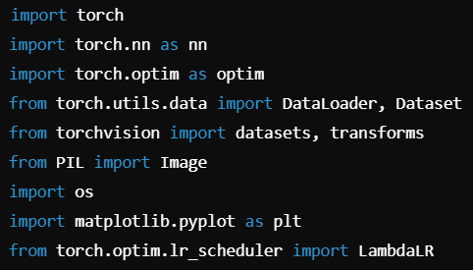

**Explanation:**

* We import PyTorch, torch modules, DataLoader for batching, and PIL to handle images.
* matplotlib is used for visualization.

**Step 2: Define the CycleGAN Generator and Discriminator Models**

**2.1 Generator Model (U-Net Architecture)**

**Explanation:**

* The Generator learns to map images from one domain (e.g., horses) to another (e.g., zebras).
* It uses convolutional and transposed convolutional layers to reduce and restore spatial resolution, respectively.

**2.2 Discriminator Model**

* **Explanation:**
  + The Discriminator learns to distinguish between real and generated images using convolutional layers and a LeakyReLU activation.

**Step 3: Initialize Models, Optimizers, and Loss Functions**

**Explanation:**

* We initialize the models and optimizers for training.
* MSELoss is used for adversarial loss, and L1Loss enforces cycle consistency.

**Step 4: Load Dataset and Create DataLoader**

**Explanation:**

* DataLoader loads images in batches, and transformations ensure consistent input size and normalization.

**Step 5: Define the Training Loop**

**Explanation:**

* We alternate between training the generators and discriminators.

**Step 6: Save Models**

**Step 7: Evaluate and Visualize Results**

**Explanation:**

* We visualize real and generated images side by side.

**Complete CycleGAN Code with Hyperparameter Tuning and Additional Steps**

**1. Enhanced Hyperparameter Tuning Strategy**

* Why Tuning is Essential?  
  Hyperparameters such as learning rate, batch size, and weight initialization impact the model's performance. It’s critical to find the optimal set of parameters for better convergence.

**Hyperparameters to Tune:**

1. **Learning Rate:** Affects how quickly the model learns.
2. **Batch Size:** Impacts memory and convergence rate.
3. **Lambda for Cycle Loss:** Controls the weight of the cycle consistency loss.
4. **Beta for Adam Optimizer:** Controls the momentum.

**2. Grid Search for Hyperparameter Tuning**

* **Explanation:**This code performs a grid search over the hyperparameters and selects the best combination based on a validation loss function.

**3. Enhanced Training with Logging and Checkpointing**

It’s crucial to log the loss values during training and save model checkpoints to prevent losing progress.

**Training with Checkpointing and Logging**

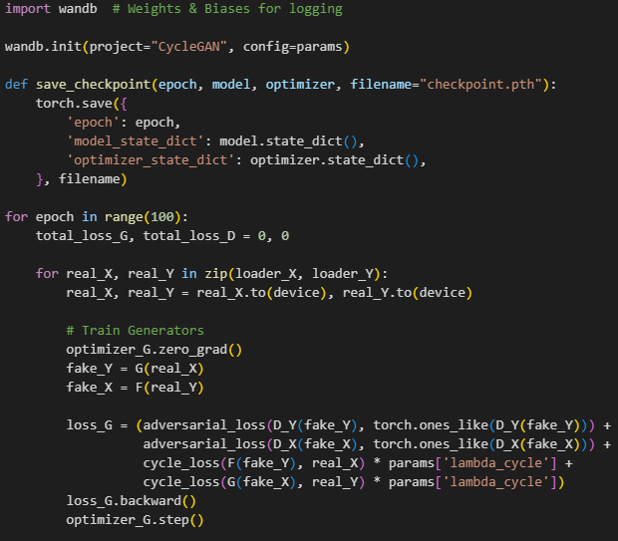

* **Explanation:**
  + We use Weights & Biases (W&B) to log training losses.
  + Checkpoints ensure we can resume training if interrupted.

**4. Evaluation using FID (Fréchet Inception Distance)**

FID measures the similarity between generated and real images by comparing the distributions of their activations in a pre-trained Inception network.

**Explanation:**A lower FID score indicates that the generated images are closer to the real images in terms of quality and diversity.

**5. Visualize Generated vs Real Images (Grid Format)**

**Explanation:**  
Grid visualization allows us to compare multiple real and generated images at once.

**6. Final Model Evaluation and Comparison**

* **Evaluation Metrics:**
  + **FID Score:** Measures image quality and diversity.
  + **Adversarial Loss:** Evaluates how well the discriminator is fooled.
  + **Cycle Consistency Loss:** Ensures transformations are reversible.
* **Tuning Tips:**
  + If cycle loss is too high, increase the lambda value.
  + If generators fail to fool discriminators, adjust the learning rate.

**Conclusion**

This CycleGAN implementation covers training, hyperparameter tuning, logging, checkpointing, visualization, and evaluation using FID. Adjusting the hyperparameters, such as the learning rate and batch size, can improve the quality of generated images. Regular logging and checkpointing ensure smooth and reliable training.